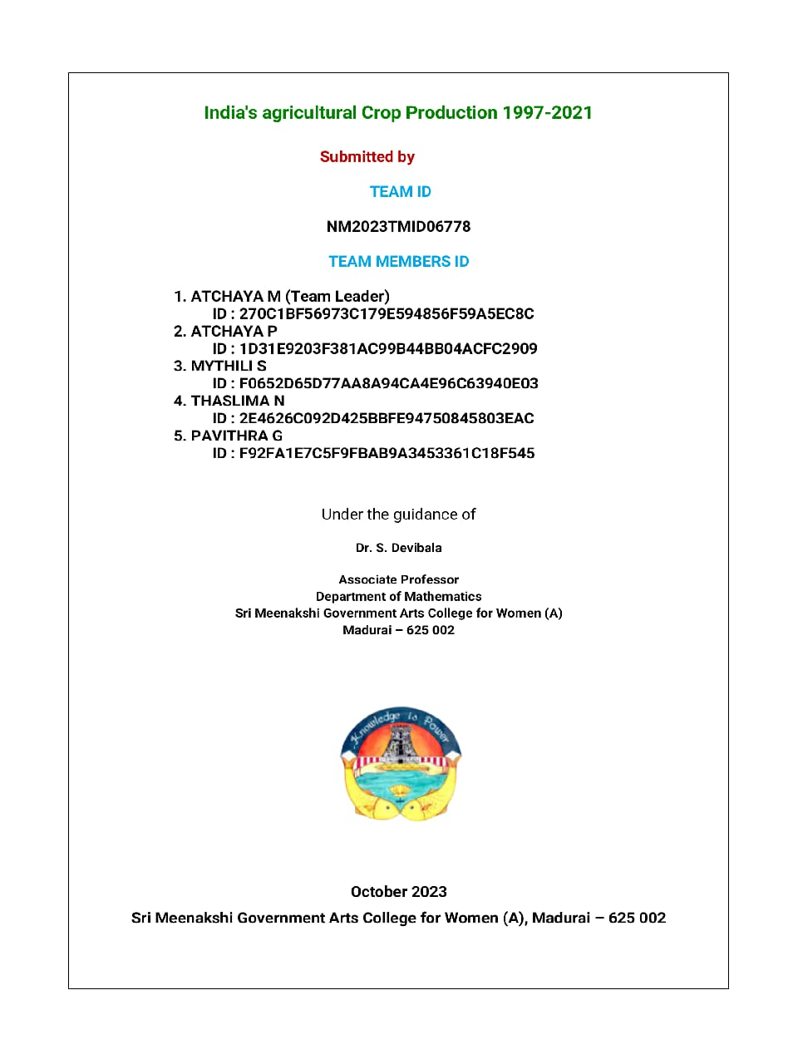

India’s Agricultural Crop Production Analysis 1997-2021
Project Report Template
1. INTRODUCTION:
1.1 Overview:
This report delves into the captivating realm of India's agricultural cultivation, providing a Comprehensive visual exploration of key aspects and trends in the agricultural sector. Through the visual representations, readers can gain valuable insights into crop production, seasonal variations, regional distribution, and overall production trends. These visualizations enable intuitive analysis, allowing stakeholders to uncover patterns, identify areas of growth or concern, and make data-driven decisions.
  - Purpose:
Visualizing the crop production, crop area and production for 1997-2021, does help farmer to make better decisions with regard crop selection.

- PROBLEM DEFINITION & DESIGN THINKING
2.1 Empathy Map:
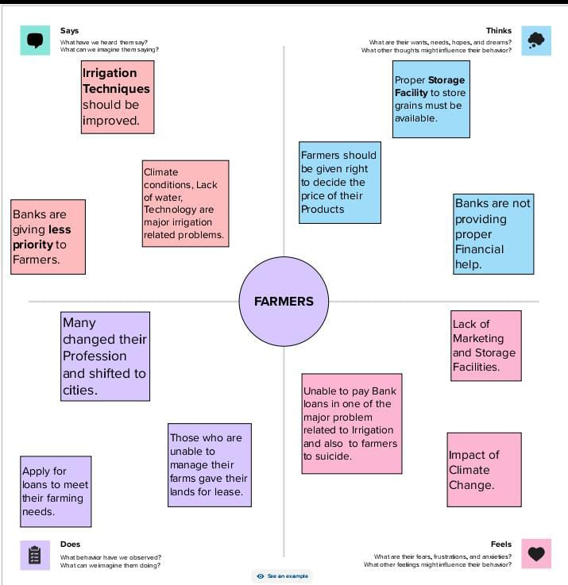

  - ideation & Brainstorming Map
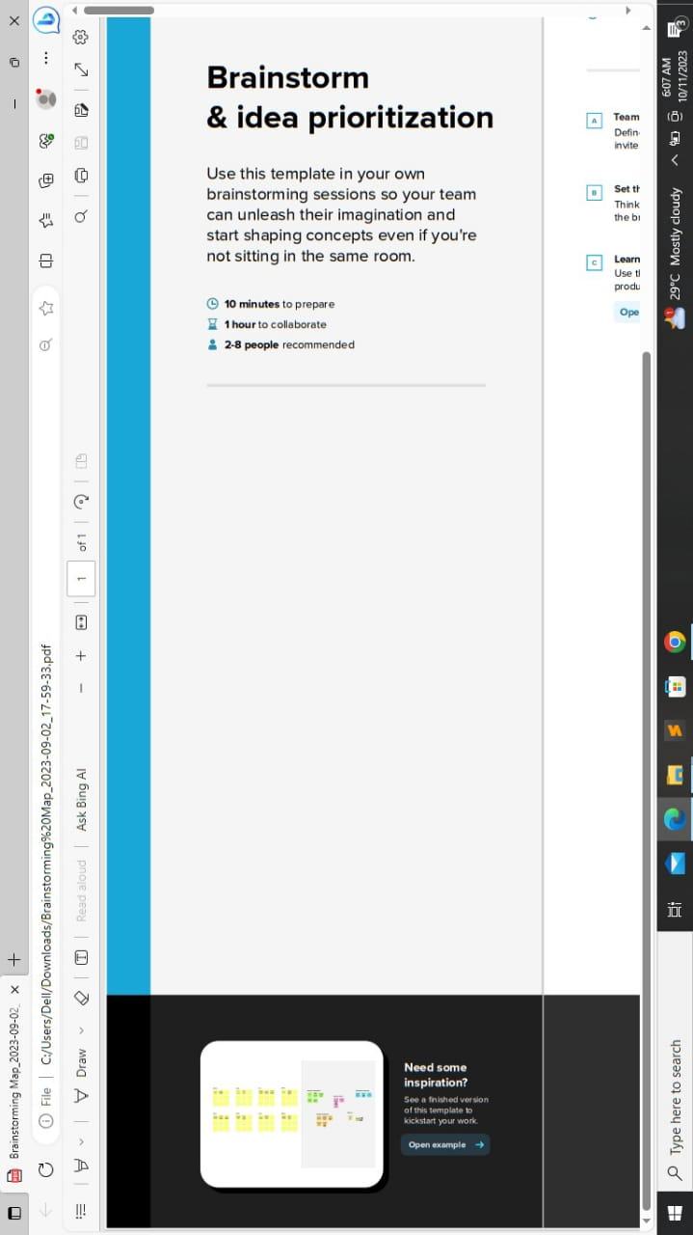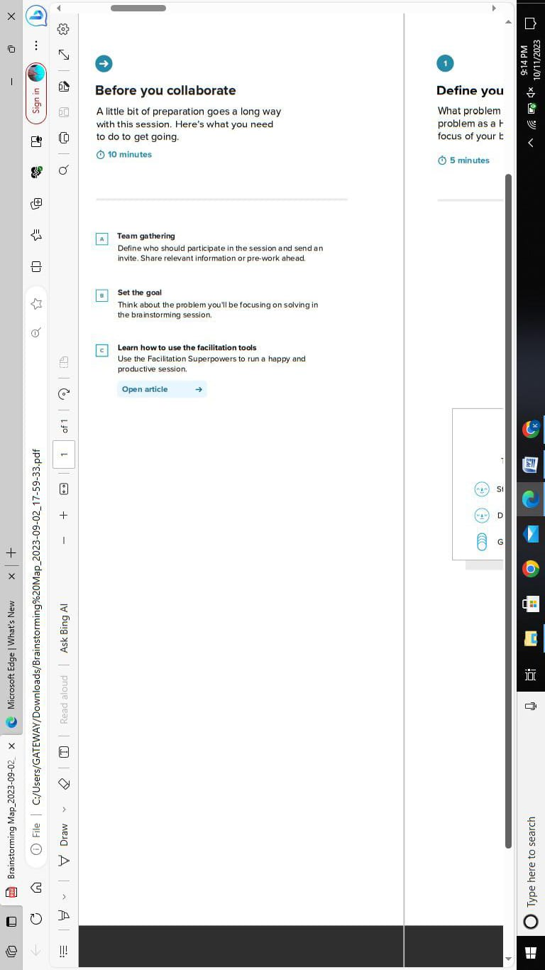
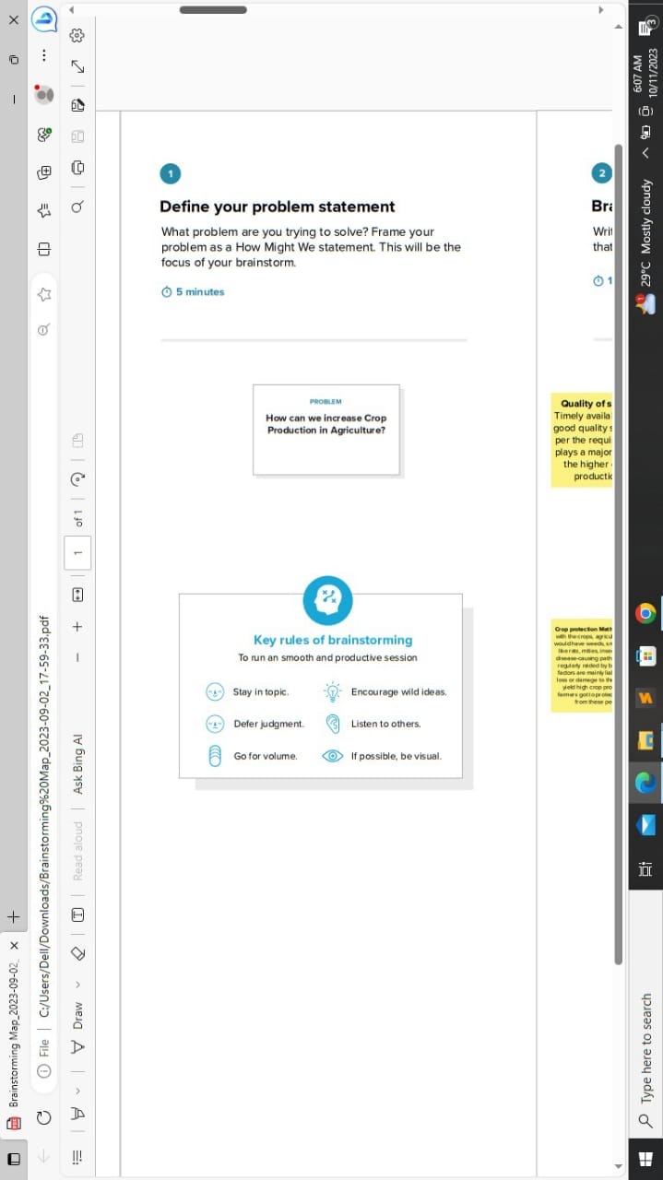

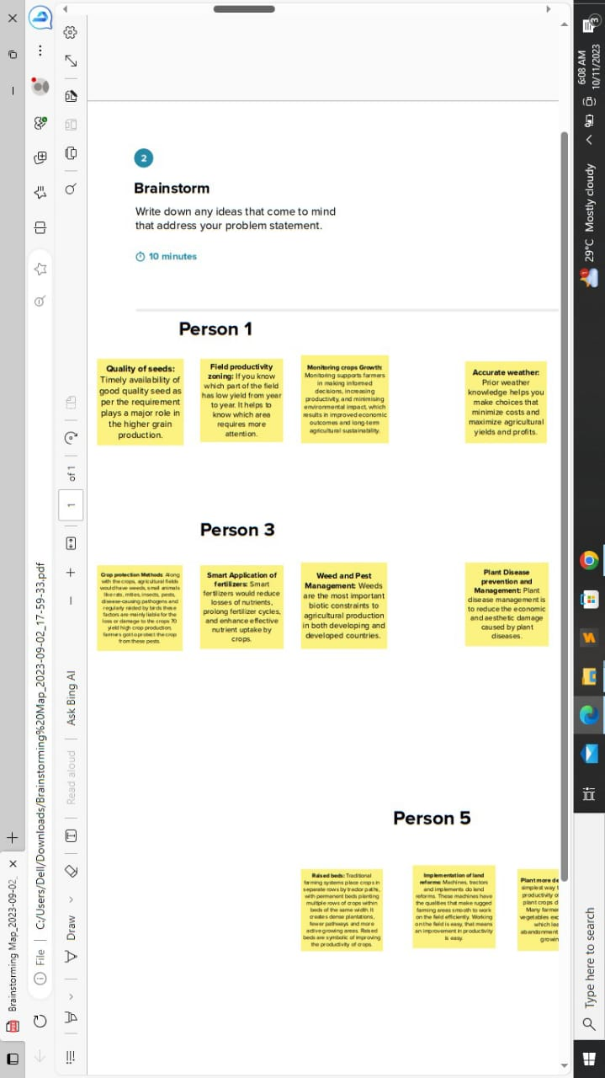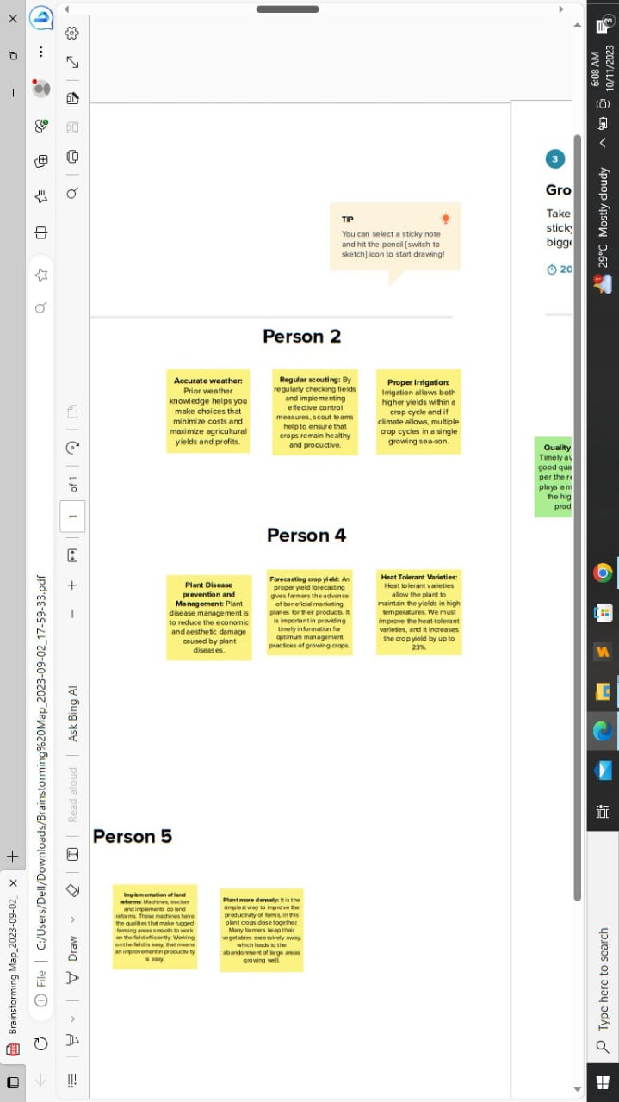
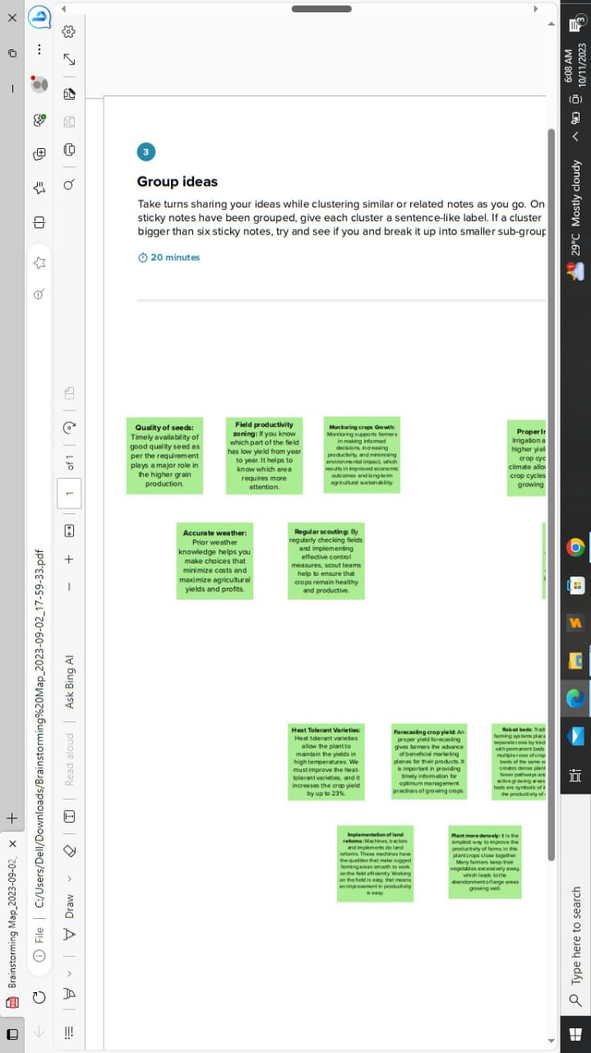
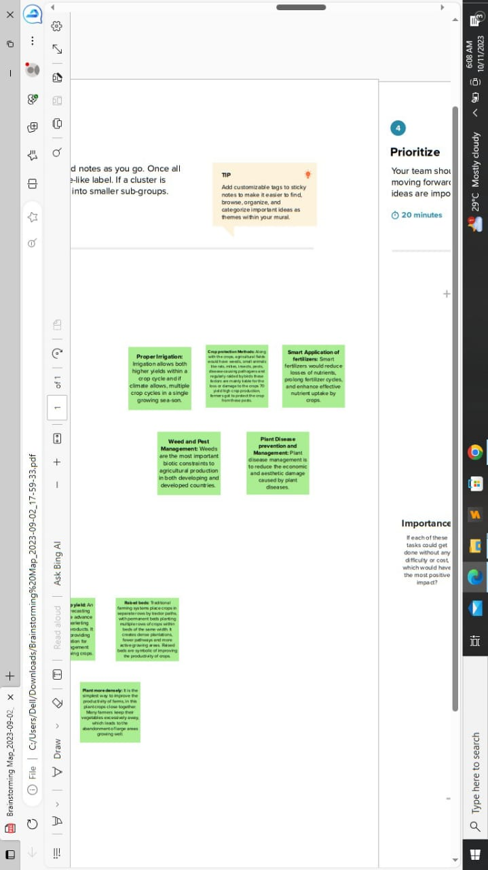
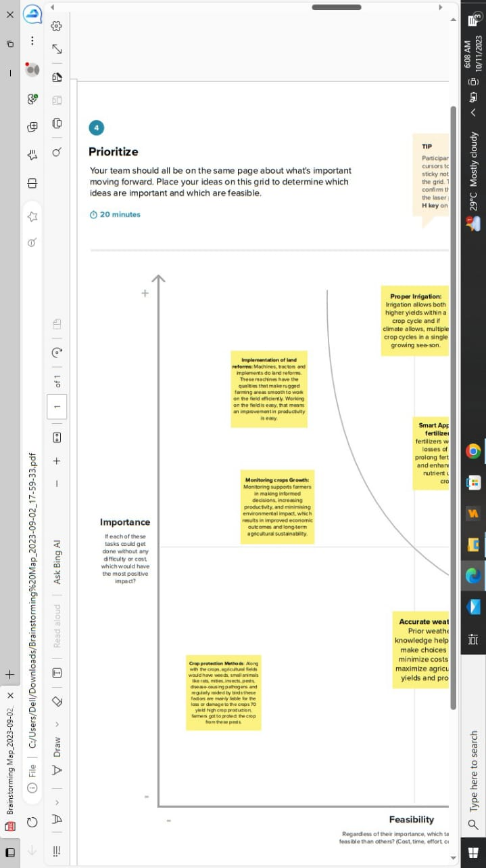
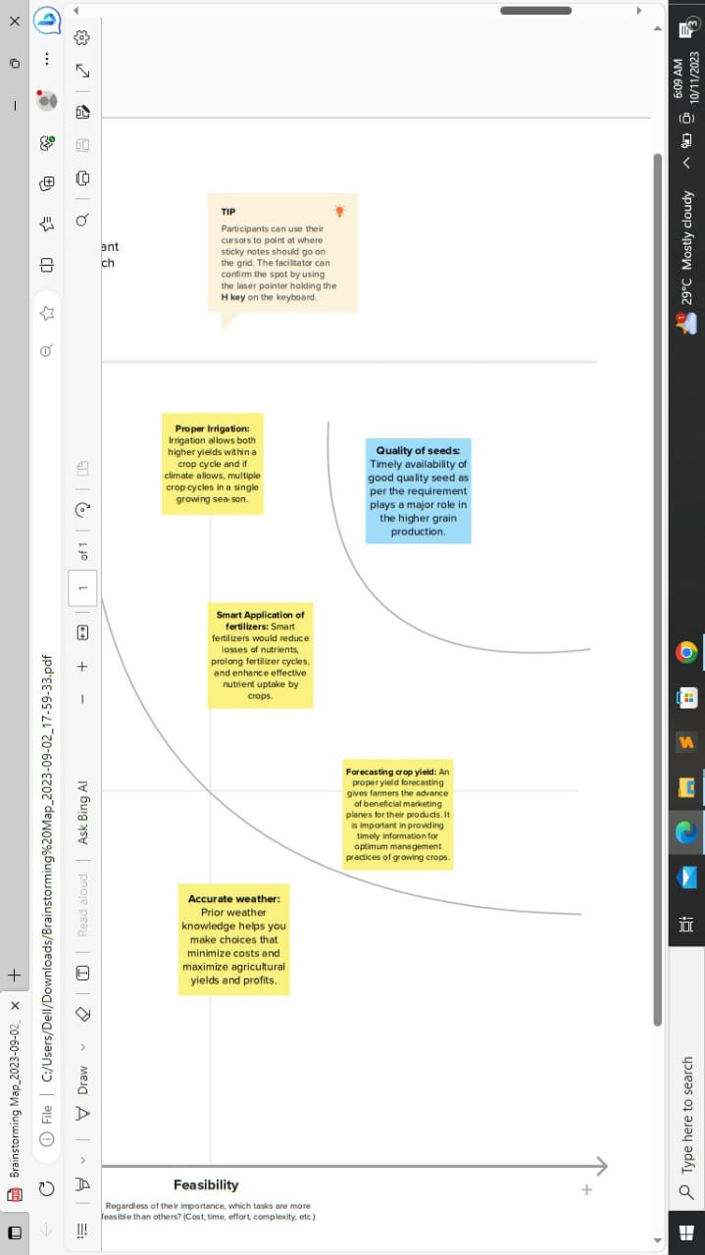
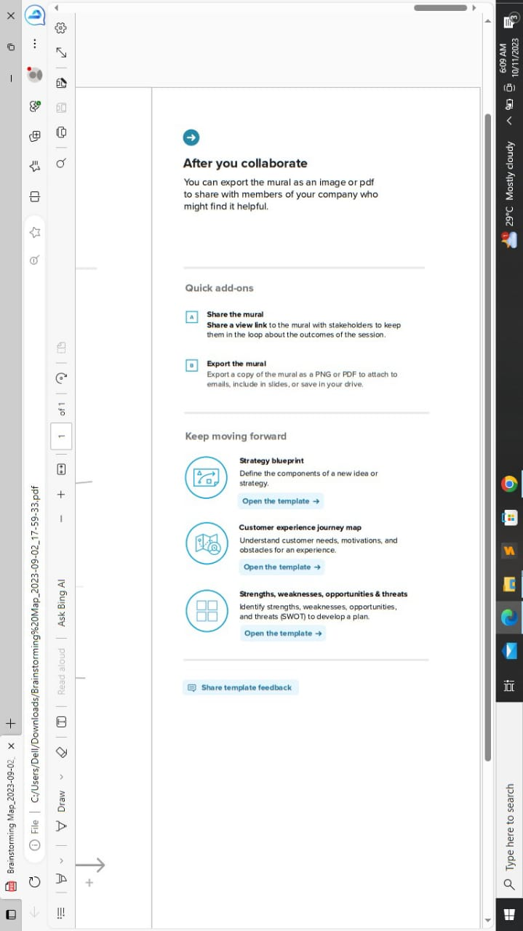

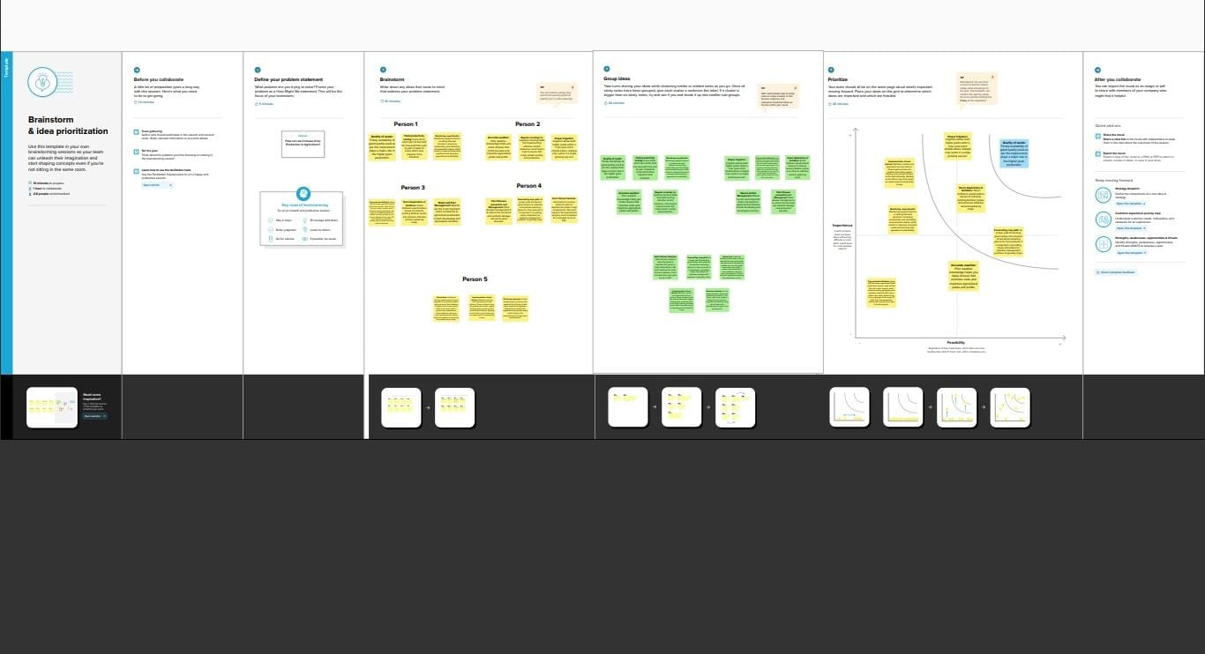
https://github.com/at20chaya/India-s-Agricultural-Crop-Production-Analysis-1997-2021-_NM2023TMID06778?search=1

- RESULT

Visualization :
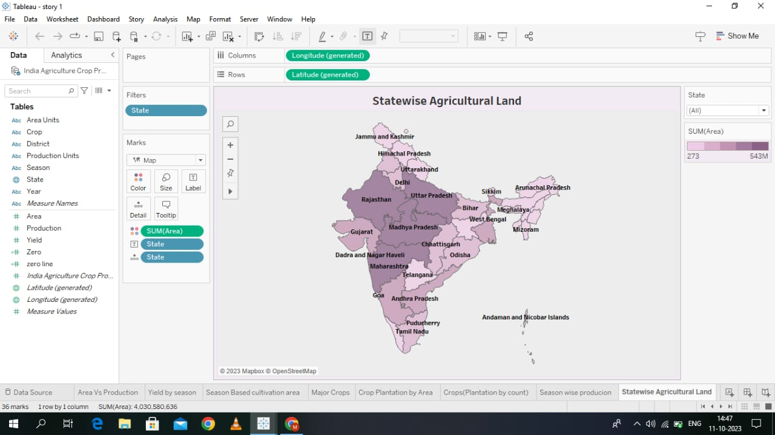

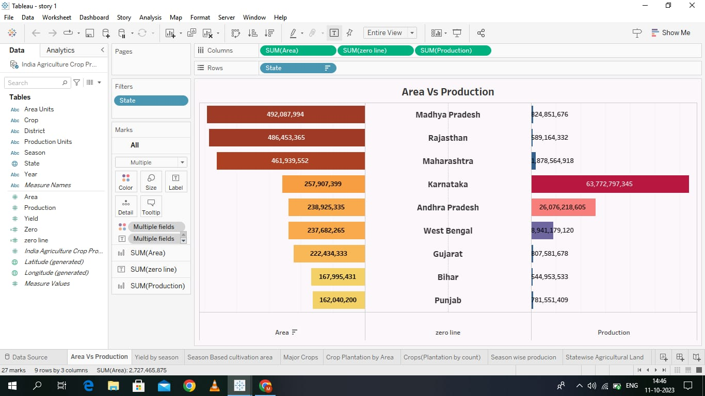

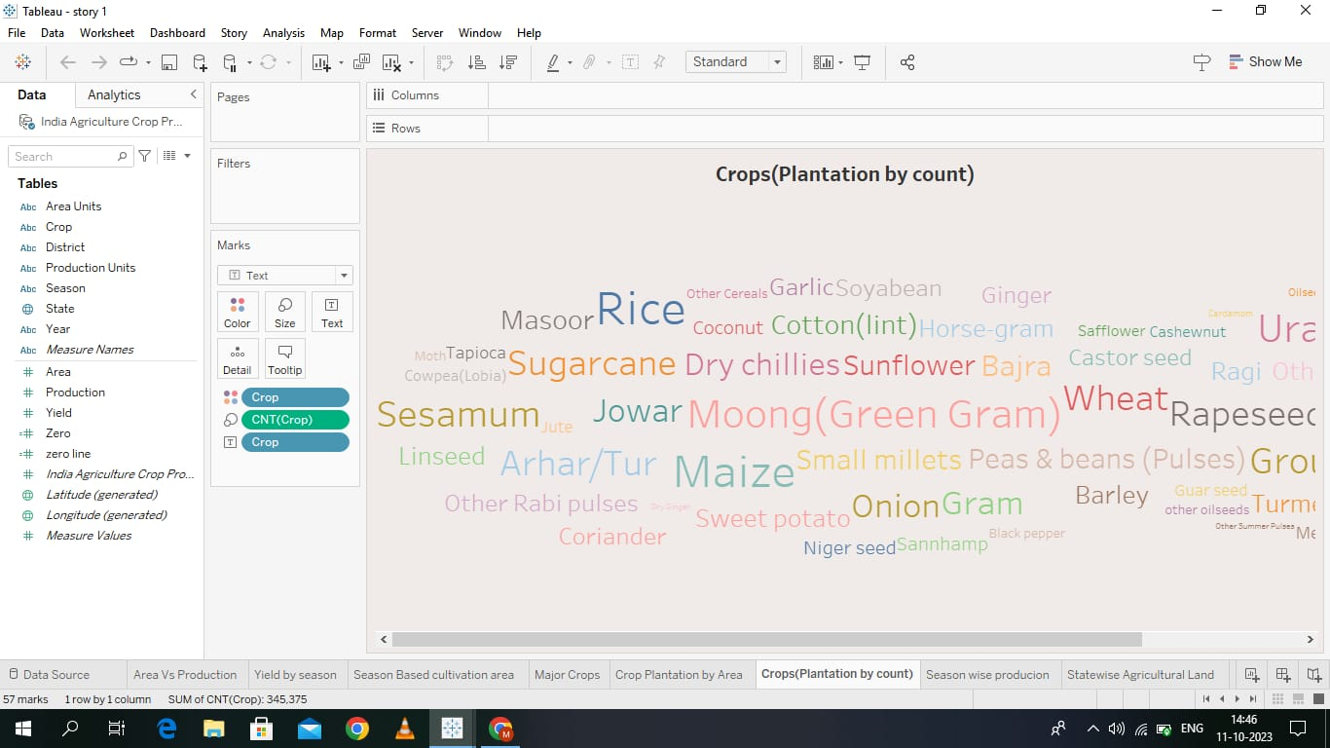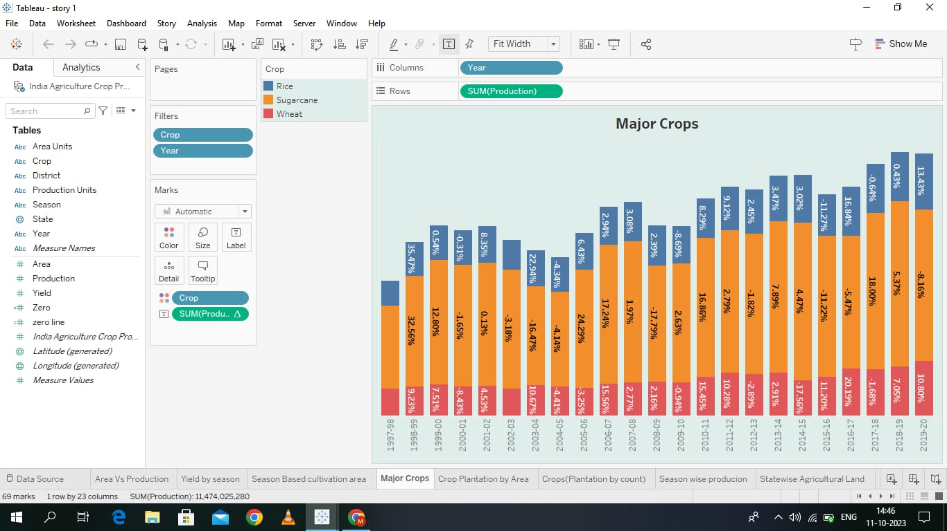

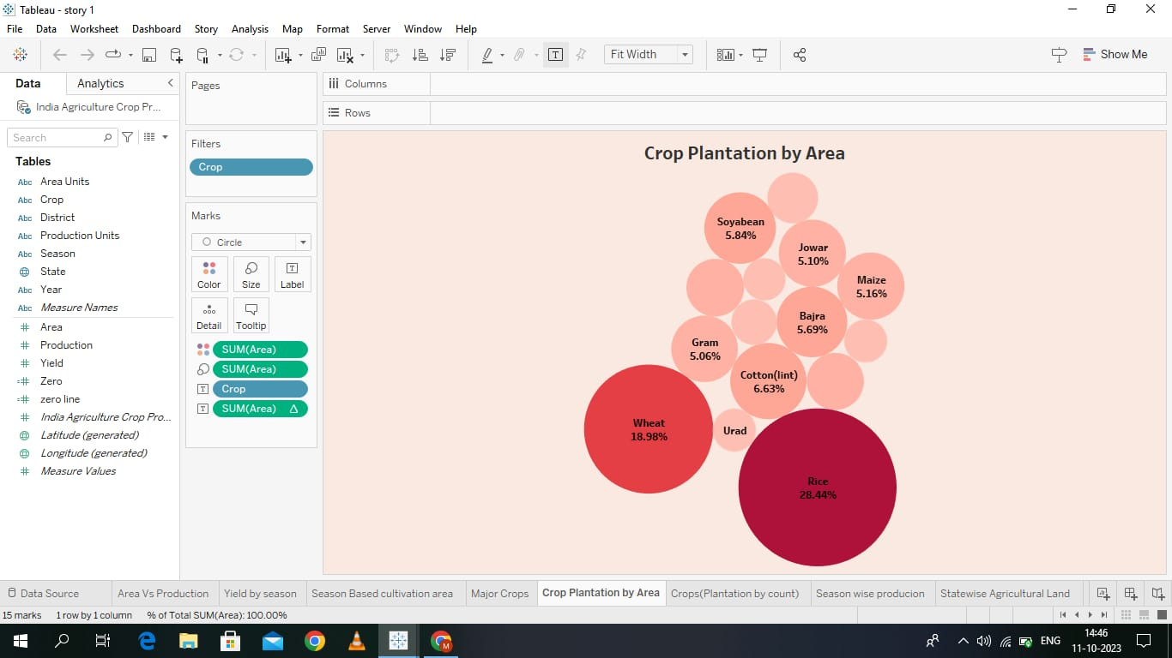
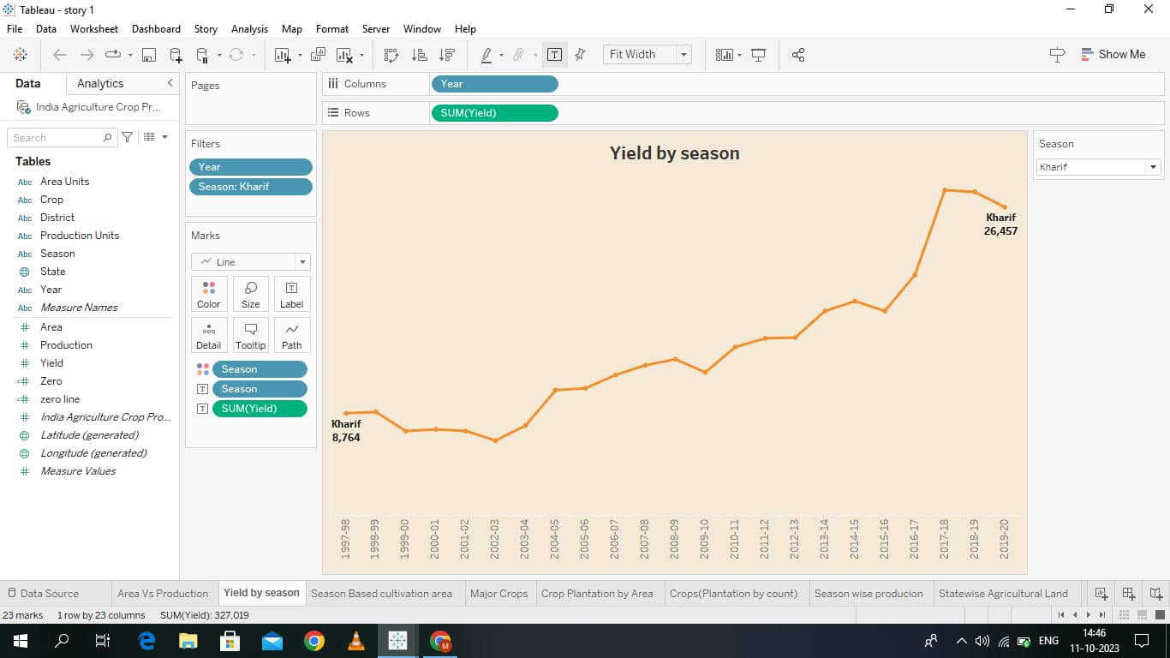
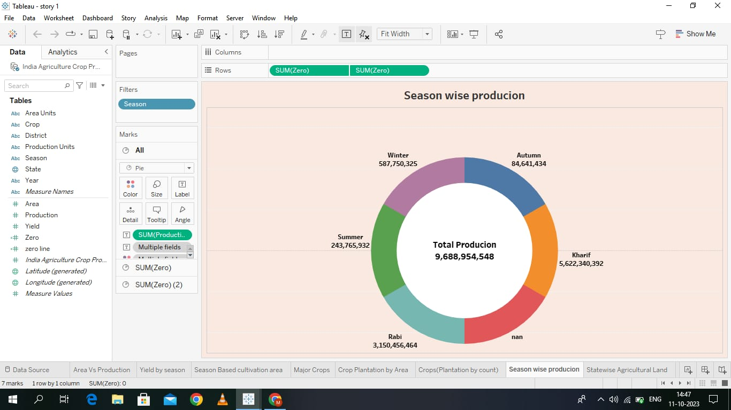
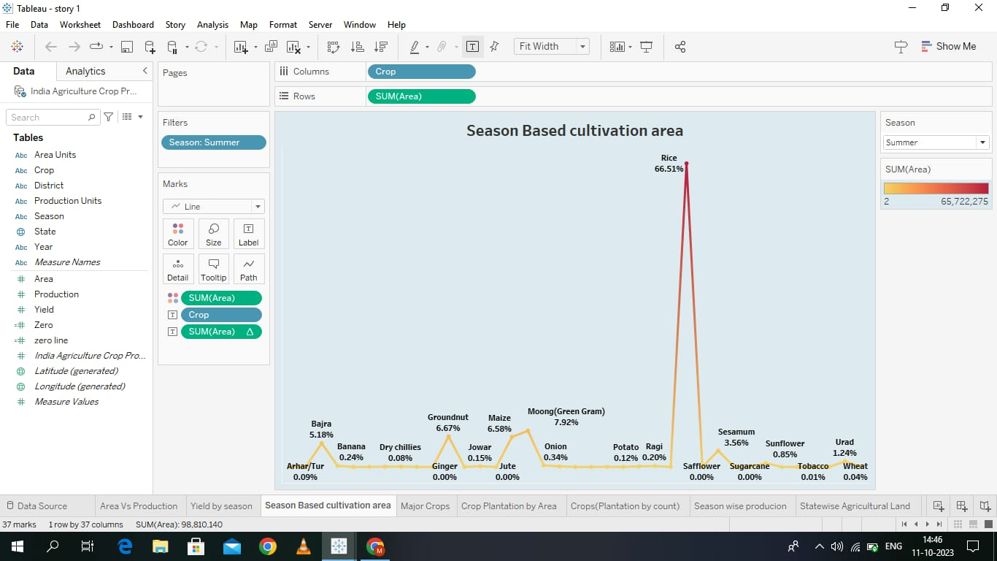

Dashboard :
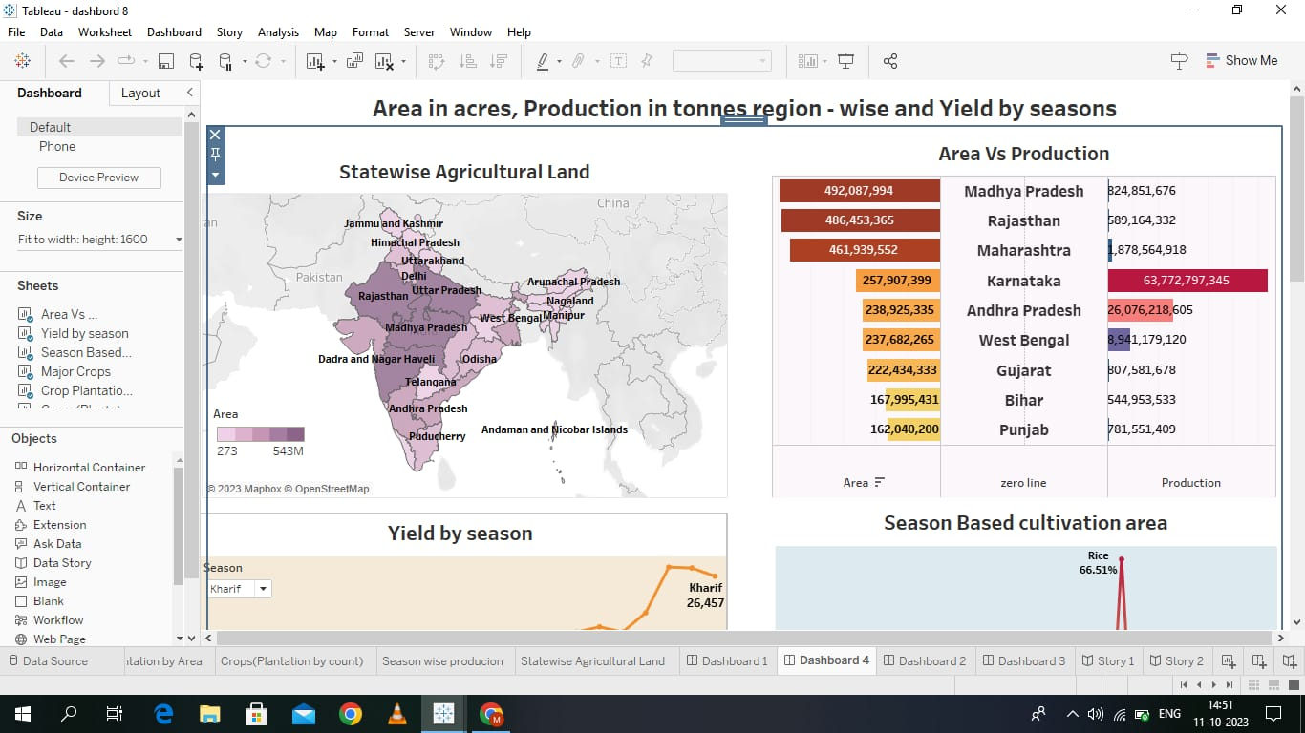
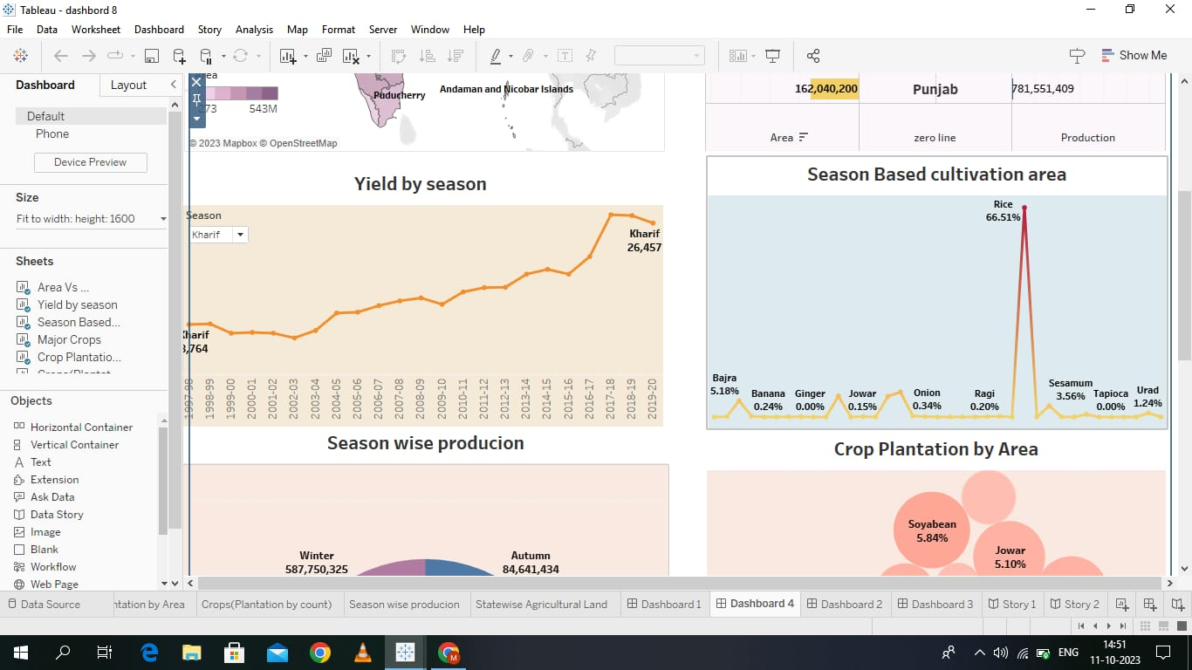

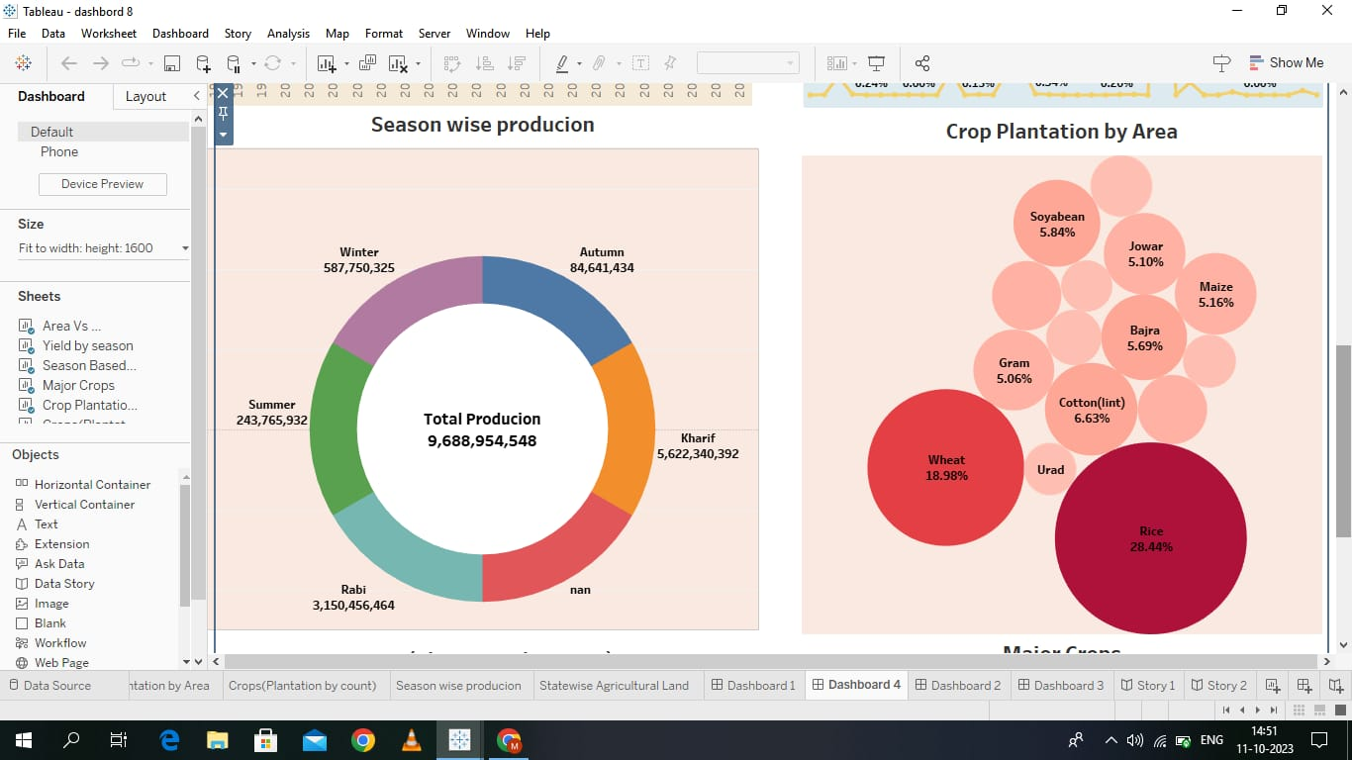
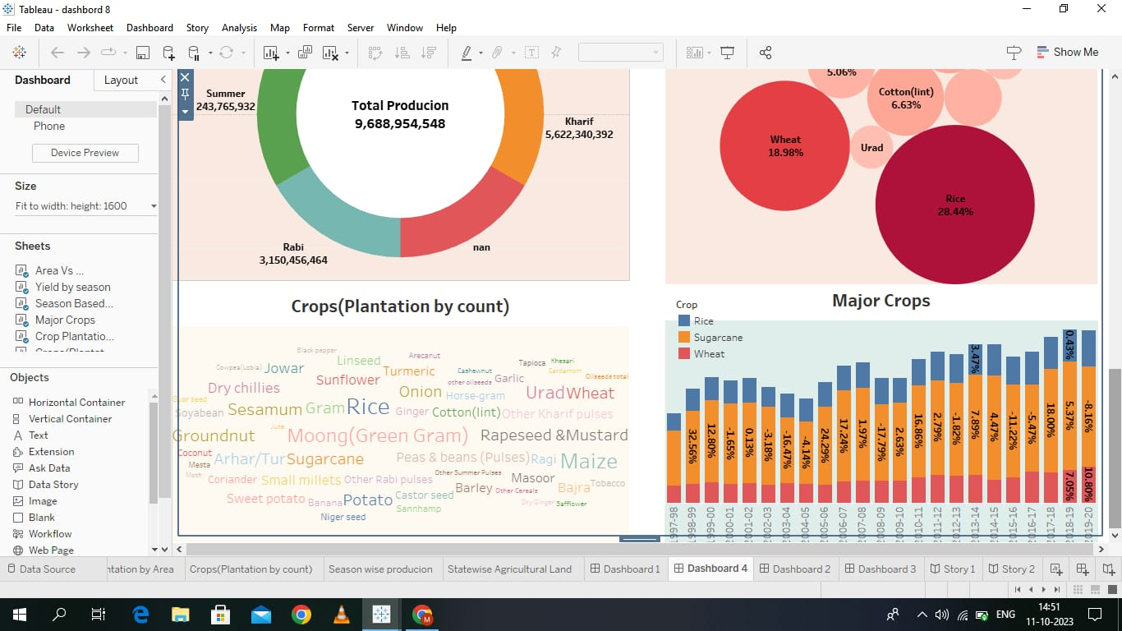
Story : 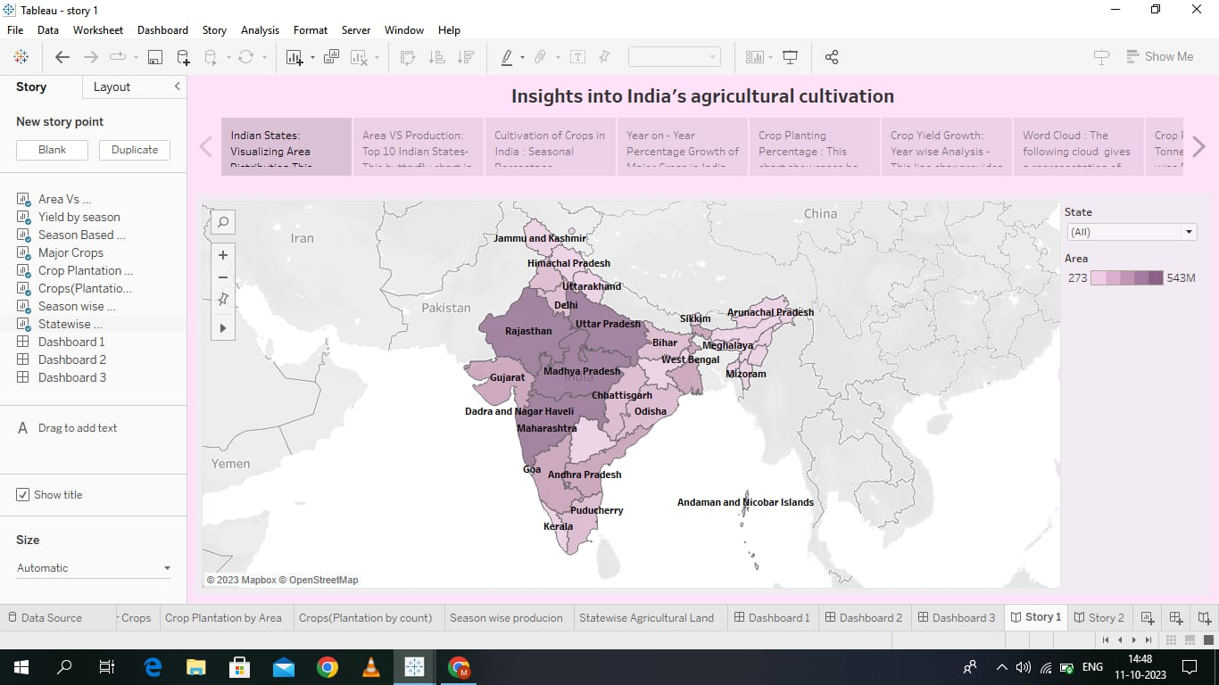
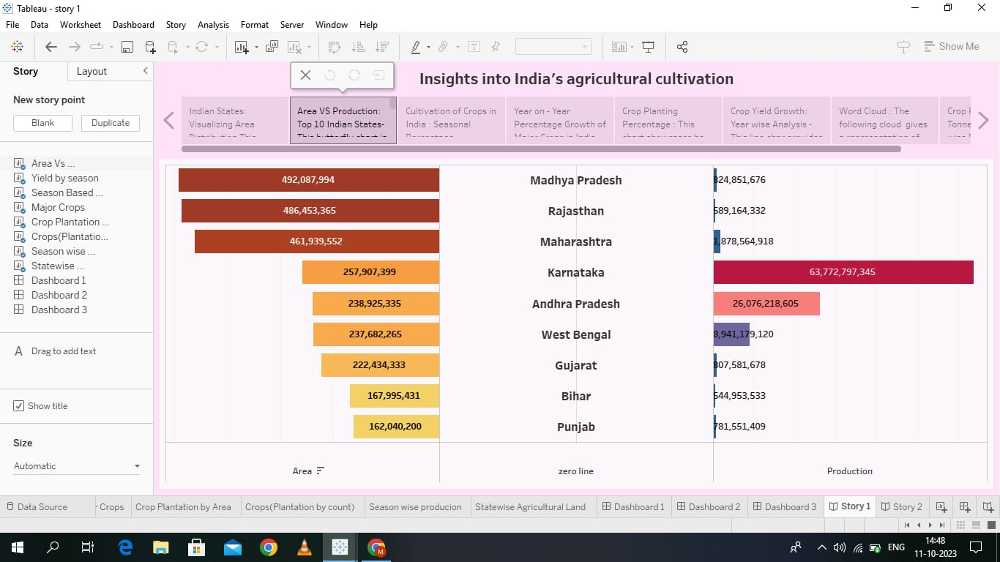

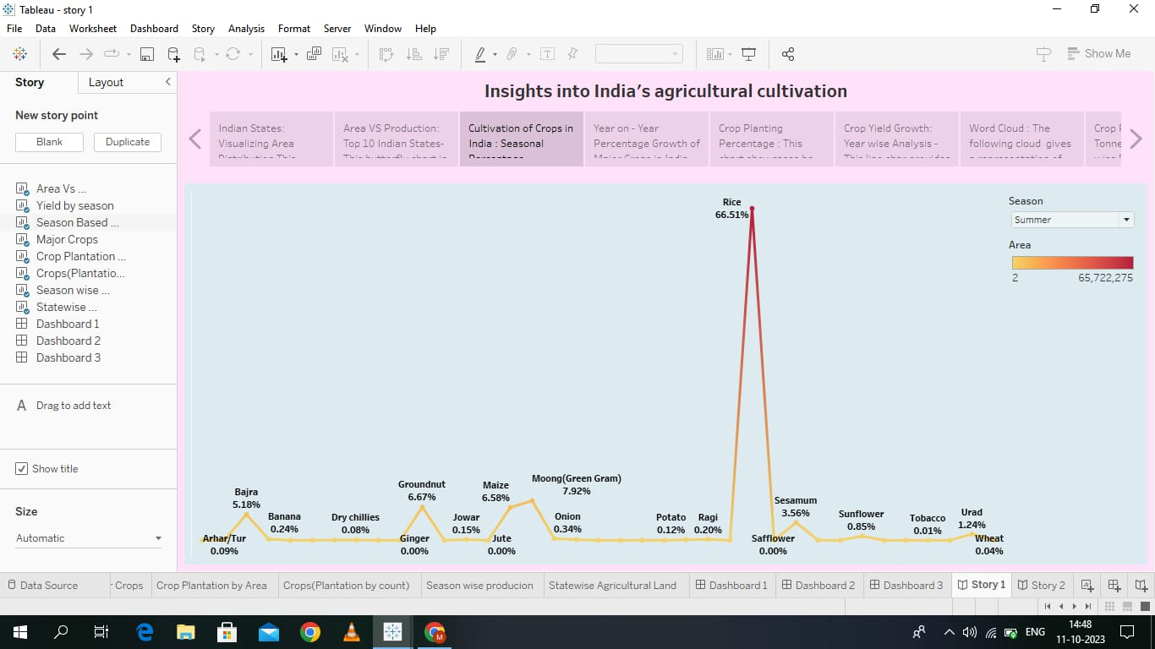
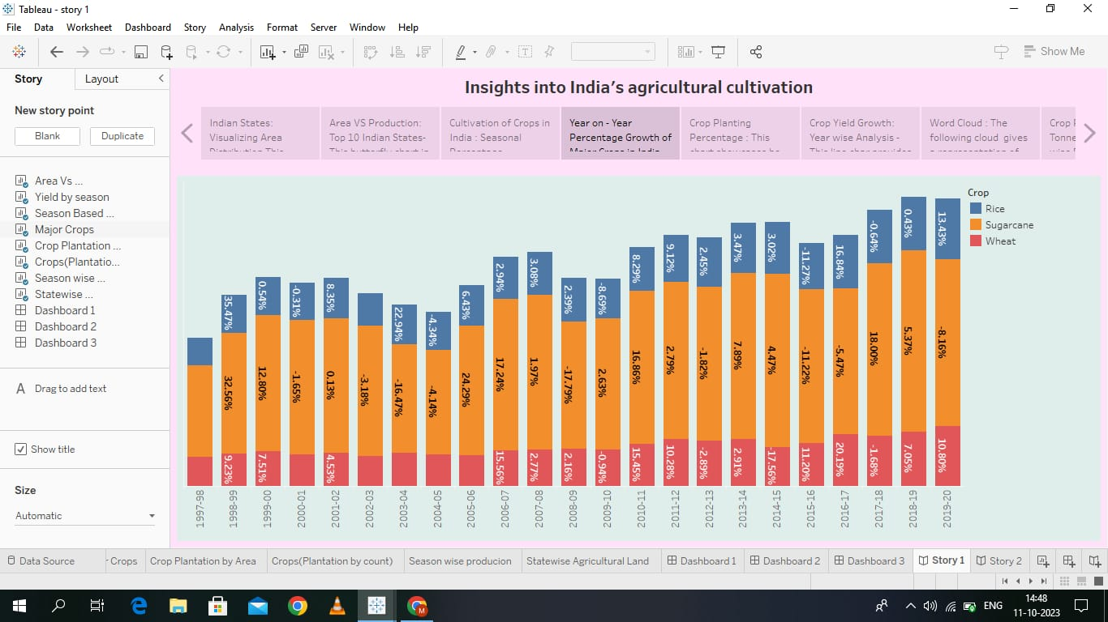
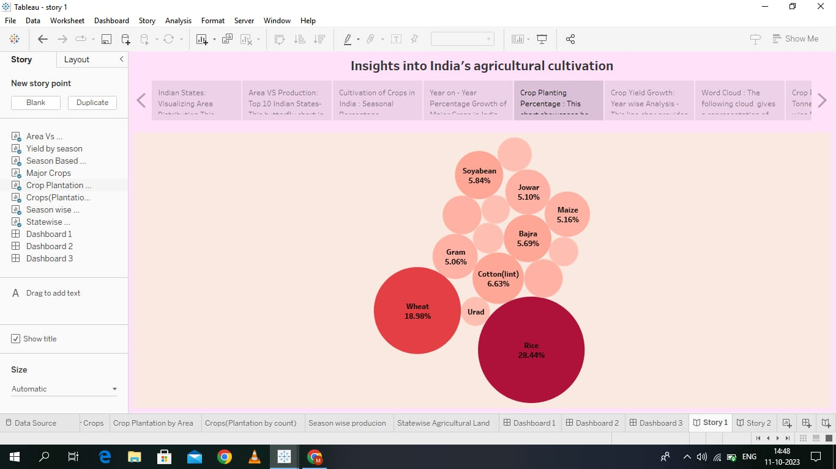
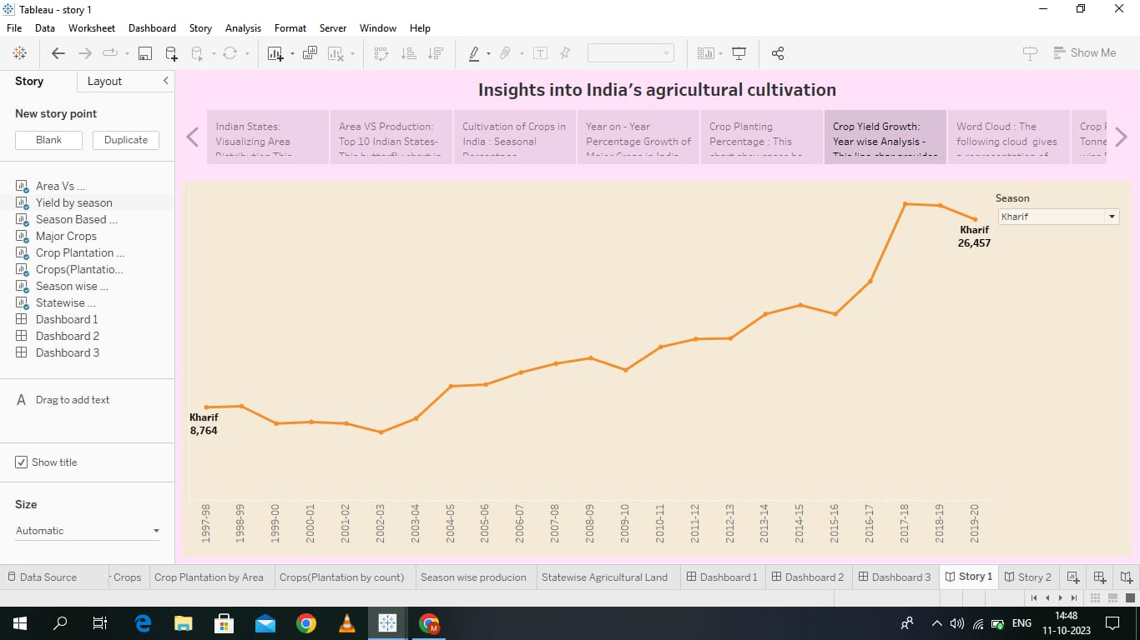
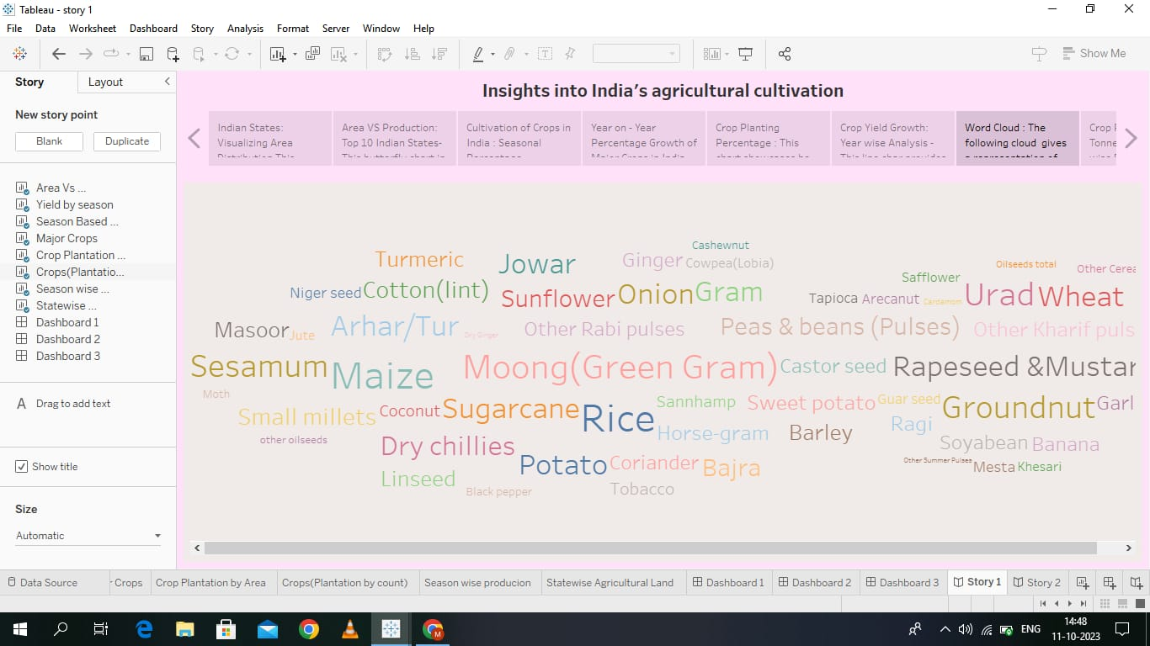
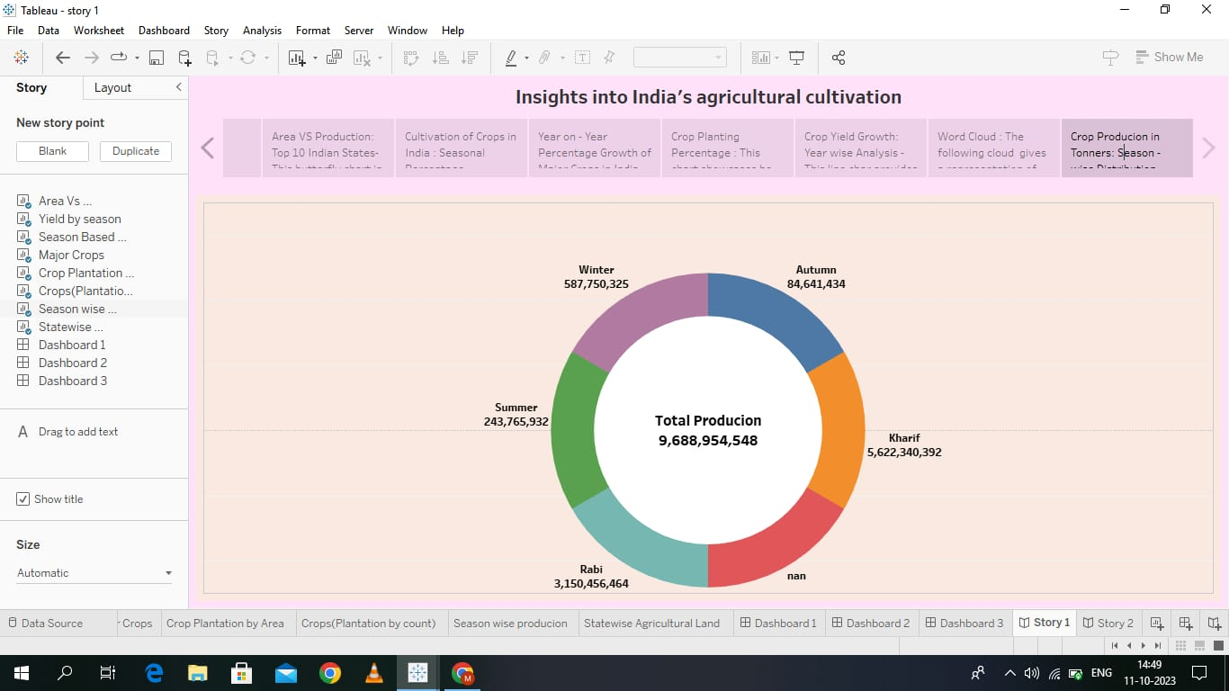
4. ADVANTAGES & DISADVANTAGES

Advantage:
>> Visualization can be used to indicate future trends and prescribe appropriate actions, such as suitable crops, best soil and changes in agronomic practices that maximize profit and minimize negative environmental impacts.
>> Enhanced efficiency and productivity with remote monitoring of soil conditions, weather patterns, crop health, and equipment performance.
>> It presents data on areas, production and sales of various agricultural products.
Disadvantages
>> Environmental degradation.
>> Depletion of specific nutrients in the soil.
>> There are limited knowledge and insufficient infrastructure in the rural areas

5. APPLICATION:
>> It helps farmers make informed decisions about their crops.
>> Agriculture employed more than 50% of the Indian workforce and contributed 20.2% to the country's GDP.
6. CONCLUSION:
The agricultural sector is of vital importance for the region. It is undergoing a process of transition to a market economy, with substantial changes in the social, legal, structural, productive and supply set-ups, as is the case with all other sectors of the economy.
7. FUTURE SCOPE:
There will be pressure on agriculture to meet future targets, so innovation will be important. Participating in biofuel will provide farmers with an opportunity to improve economic efficiency. It will also create competition between food and fuel producers for valuable crops.

